Following are the steps to set up the Android emulator (or Samsung emulator)

1. Navigate <https://developer.samsung.com/galaxy/emulator-skin> and download desire Samsung device skins.
2. Now navigate platform tools location and extract the above skins in required android version as mentioned below:

C:\Users\hiteshg\AppData\Local\Android\Sdk\platforms\android-25\skins

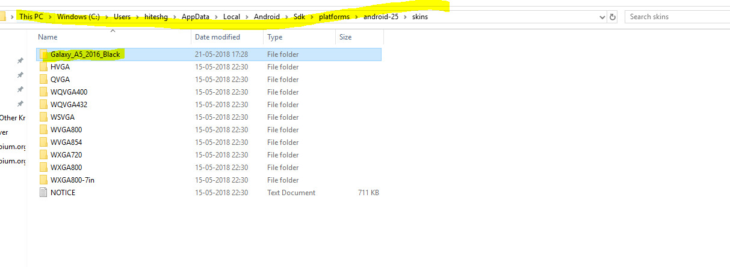

1. Now open command prompt and issue ‘android avd’ command to open the android virtual device manager
2. Go to Device Definition tab and click on ‘Create Device’ button and provide the following emulator details.

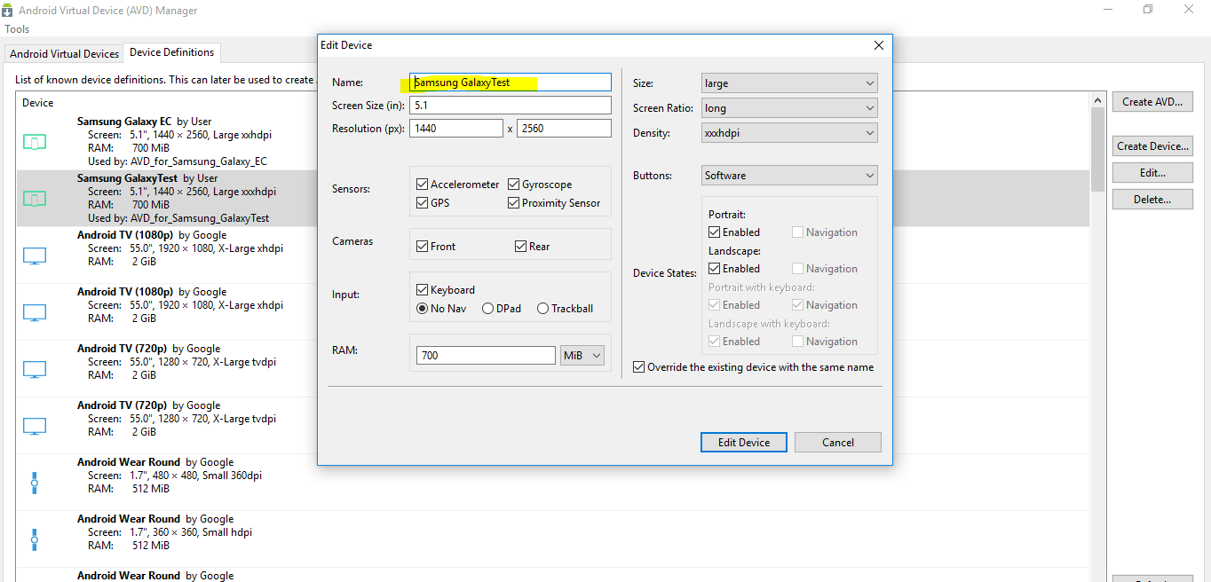

1. Create and save it.
2. It will start listing down in device definitions list.

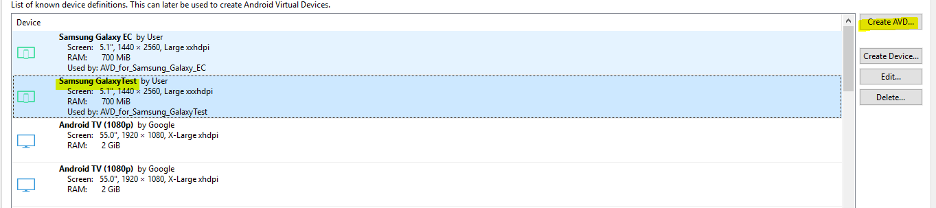

1. Now click on ‘Create avd’ button.
2. As soon as above button is clicked, configure the following

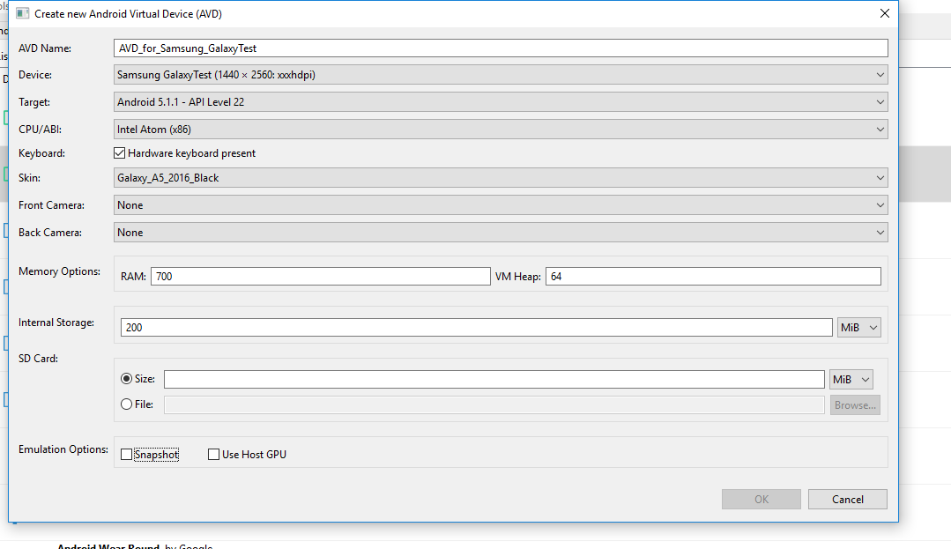

1. Come back to ‘Android Virtual Devices’ tab and start the above emulator.

The following device will be opened after starting it.

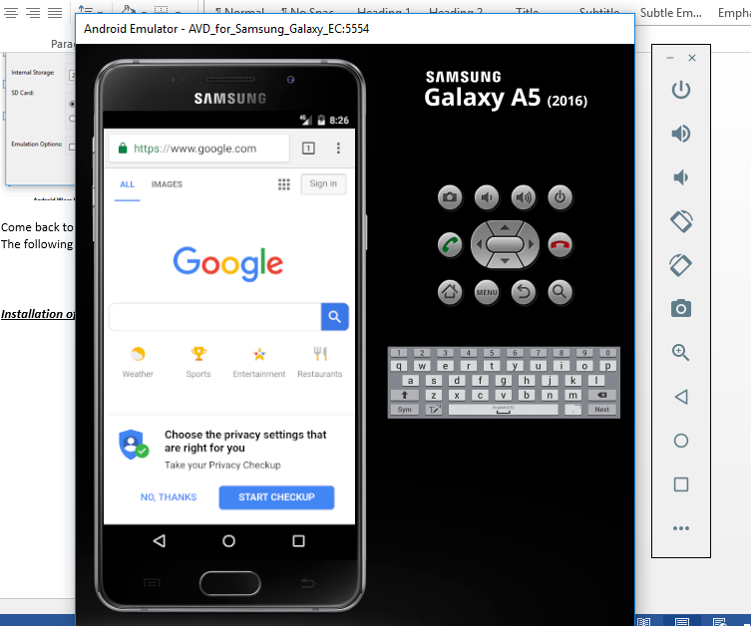

***Installation of chrome browser (.apk) on emulator***

By default, the chrome browser is not installed in emulator. We have to install it.

Step 1: Search google as ‘Chrome browser for x86’ and download the latest chrome browser .apk.

Step 2: Now drag this apk file into emulator.

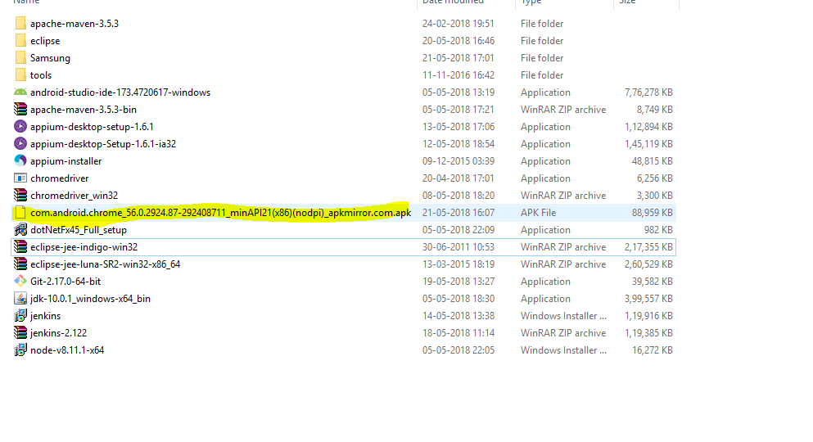

Step3: After installing it, open the chrome browse as above.